The caption on figure 5.56 should read Dictionary skeleton for Exercise 5.21
CHAPTER 5
Hashing
5.1 (a) On the assumption that we add collisions to the end of the list (which is the easier way if a hash table is being built by hand), the separate chaining hash table that results is shown here.
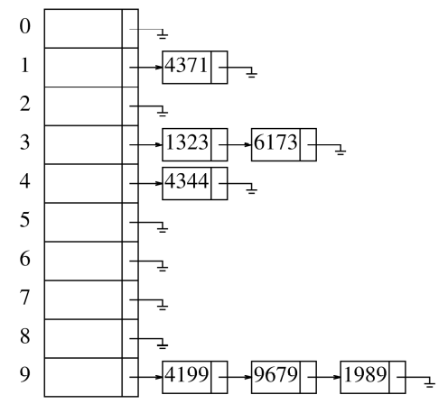
(b) 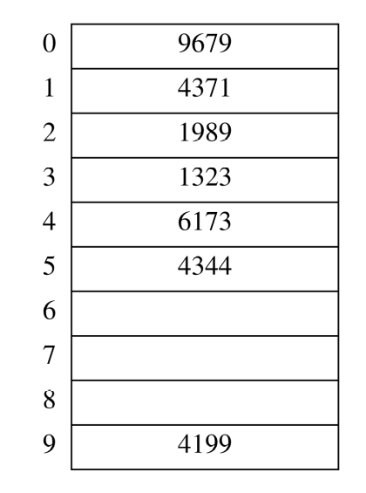
(c) 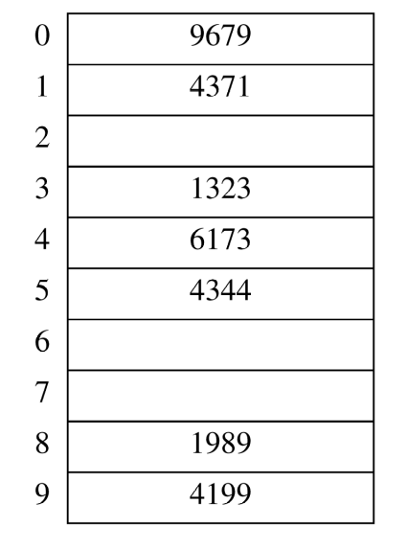
(d) 1989 cannot be inserted into the table because hash₂(1989) = 6, and the alternative locations 5, 1, 7, and 3 are already taken. The table at this point is as follows:
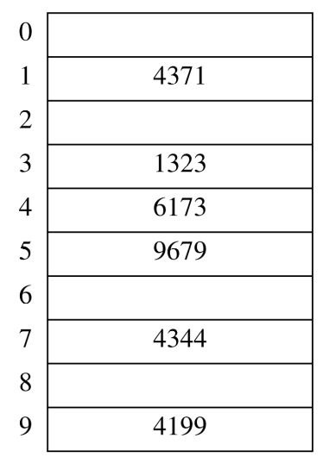
5.2 When rehashing, we choose a table size that is roughly twice as large and prime. In our case, the appropriate new table size is 19, with hash function h(x) = x(mod 19).
(a) Scanning down the separate chaining hash table, the new locations are 4371 in list 1, 1323 in list 12, 6173 in list 17, 4344 in list 12, 4199 in list 0, 9679 in list 8, and 1989 in list 13.
(b) The new locations are 9679 in bucket 8, 4371 in bucket 1, 1989 in bucket 13, 1323 in bucket 12, 6173 in bucket 17, 4344 in bucket 14 (because both 12 and 13 are already occupied), and 4199 in bucket 0.
(c) The new locations are 9679 in bucket 8, 4371 in bucket 1, 1989 in bucket 13, 1323 in bucket 12, 6173 in bucket 17, 4344 in bucket 16 (because both 12 and 13 are already occupied), and 4199 in bucket 0.
(d) The new locations are 9679 in bucket 8, 4371 in bucket 1, 1989 in bucket 13, 1323 in bucket 12, 6173 in bucket 17, 4344 in bucket 15 because 12 is already occupied, and 4199 in bucket 0.

5.3 For simplicity only integers will be hashed and the hash function h(x) = x %D where D is the user input size of the table. The simulation continues until the quadratic hashing fails.
Typical results for table size 1001
Linear Collisions : 5983
Quadratic Collisions : 2379
Double Hash Collisions : 258
#include<iostream>
#include<vector>
#include<cmath>
#include<ctime>
using namespace std;

int insertLinear(int x, vector<int> & linear);
int insertQuad(int x, vector<int> & quad);
int insertDuble(int x, int dubHash, vector<int> & duble);

int main()
{
int linCollides=0;
int quadCollides= 0;
int dubCollides = 0;
int quadInc;
int tableSize;
bool fail = false;
int x, count=0;
int doubleHash;

srand(time(NULL));
cout<<"enter the size of the table ";
cin>>tableSize;
vector<int> linear(tableSize,-1);//initalize each table to -1 for empty
vector<int> quad(tableSize,-1); //initalize each table to -1 for empty
vector<int> duble(tableSize,-1); //initalize each table to -1 for empty
do{
doubleHash = rand()%tableSize;
}while (doubleHash < tableSize/10 && doubleHash%tableSize==0);
while(count < tableSize && !fail)
{
x= rand()%tableSize;// value to insert
quadInc=insertQuad(x,linear);
if (quadInc < 0)
fail = true;
else
{
quadCollides += quadInc;
linCollides+=insertLinear(x,linear);
dubCollides+=insertDuble(x,doubleHash, duble);
}
count++;
}
cout<<"Num linear collides "<<linCollides<<endl;
cout<<"Num quadratic collides "<<quadCollides<<endl;
cout<<"Num double hash collides "<<dubCollides<<endl;
return 0;
}
int insertLinear(int x, vector<int> & linear)
{
int collides=0;
while(collides < linear.size() && linear[x] >=0)
{
collides++;
x+=1;
x= x % linear.size();
}
linear[x] = x;
return collides;
}
int insertQuad(int x, vector<int> & quad)
{
int collides=0;
int probeDist= 1;
int probeDiff =1;
bool fail = false;

while(collides < quad.size() && quad[x] >=0 && !fail)
{
collides++;
x+=probeDist;
x= x % quad.size();
probeDiff +=2;
probeDist += probeDiff;
if (probeDiff >quad.size())
fail= true;
}
if (fail || collides>=quad.size())
return -1;
else
{
quad[x] = x;
return collides;
}
}
int insertDuble(int x, int dubHash, vector<int> & duble)
{
int collides=0;
while(collides< duble.size() && duble[x] >=0)
{
collides++;
x+=dubHash;
x= x% duble.size();
}
duble[x] = x;
return collides;
}
5.4 We must be careful not to rehash too often. Let p be the threshold (fraction of table size) at which we rehash to a smaller table. Then if the new table has size N, it contains 2pN elements. This table will require rehashing after either 2N − 2pN insertions or pN deletions. Balancing these costs suggests that a good choice is p = 2/3. For instance, suppose we have a table of size 300. If we rehash at 200 elements, then the new table size is N = 150, and we can do either 100 insertions or 100 deletions until a new rehash is required.
If we know that insertions are more frequent than deletions, then we might choose p to be somewhat larger. If p is too close to 1.0, however, then a sequence of a small number of deletions followed by insertions can cause frequent rehashing. In the worst case, if p = 1.0, then alternating deletions and insertions both require rehashing.

5.5 This problem is in error, as the implementation in the text already uses a vector of lists.
5.6 No; this does not take deletions into account.
5.7 (b) If the number of deleted cells is small, then we spend extra time looking for inactive cells that are not likely to be found. If the number of deleted cells is large, then we may get improvement.
5.8 Cubic probing encounters slightly fewer collisions than quadratic probing, as seen in the following simulation.
// Let's simulate linear, quadratic, and cubic probing.
// Is cubic probing any better than quadratic?
// In this simulation, cells equal to 0 represent empty, and cells
// equal to 1 contain some key value.
#include<iostream>
#include<vector>
#include<cmath>
using namespace std;
const int SIZE = 9001; // prime number over 9,000
const int MAX = 4500;

int main()
{
vector<int>linear(SIZE, -1);
vector<int>quadratic(SIZE,-1);
vector<int>cubic(SIZE,-1);

int linearCollisions = 0;
int quadraticCollisions = 0;
int cubicCollisions = 0;

// We are going to generate random indices to occupy in the hash tables.
srand(0);
for (int i = 0; i < MAX; ++i)
{
int hashCode = rand()% SIZE;
int offset = 0;
while (linear[hashCode] == 1)
{
++linearCollisions;
++offset;
hashCode += offset;
hashCode %= SIZE;
}
linear[hashCode] = 1;
}

srand(0);
for (int i = 0; i < MAX; ++i)
{
int hashCode = rand()% SIZE;
int offset = 0;
while (quadratic[hashCode] == 1)
{
++quadraticCollisions;
++offset;
hashCode += offset * offset;
if (hashCode >= SIZE)
hashCode %= SIZE;
}
quadratic[hashCode] = 1;
}
srand(0);
for (int i = 0; i < MAX; ++i)
{
int hashCode = rand()% SIZE;
int offset = 0;
while (cubic[hashCode] == 1)
{
++cubicCollisions;
++offset;
hashCode += offset * offset * offset;
if (hashCode >= SIZE)
hashCode %= SIZE;
}
cubic[hashCode] = 1;
}

cout<<"Here is the number of collisions for each type of probing.\n";
cout<<"linear = "<<linearCollisions<<endl;
cout<<"quadratic = "<< quadraticCollisions<<endl;
cout<<"cubic = "<< cubicCollisions<<endl;
return 0;
}

5.10 Separate chaining hashing requires the use of links, which costs some memory, and the standard
method of implementing calls on memory allocation routines, which typically are expensive. Linear
probing is easily implemented, but performance degrades severely as the load factor increases because
of primary clustering. Quadratic probing is only slightly more difficult to implement and gives
good performance in practice. An insertion can fail if the table is half empty, but this is not likely.
Even if it were, such an insertion would be so expensive that it wouldn’t matter and would almost
certainly point up a weakness in the hash function. Double hashing eliminates primary and secondary
clustering, but the computation of a second hash function can be costly. Gonnet and Baeza-Yates [19]
compare several hashing strategies; their results suggest that quadratic probing is the fastest method.
5.11 In the case of a collision this method uses a pseudorandom number to make jumps away from the
home bucket. However the length of the jump the same for each home bucket. This would avoid
secondary clustering near the home bucket. It is a special case of double hashing in that the jumps
away from the home bucket are fixed as contrasted by double hashing where the jumps grow at
each jump.
5.12 The old values would remain valid if the hashed values were less than the old table size.
5.13 Sorting the MN records and eliminating duplicates would require O(MN log MN) time using a
standard sorting algorithm. If terms are merged by using a hash function, then the merging time is
constant per term for a total of O(MN). If the output polynomial is small and has only O(M + N)
terms, then it is easy to sort it in O((M + N) log(M + N)) time, which is less than O(MN). Thus
the total is O(MN). This bound is better because the model is less restrictive: Hashing is performing
operations on the keys rather than just comparison between the keys. A similar bound can be obtained
by using bucket sort instead of a standard sorting algorithm. Operations such as hashing are much
more expensive than comparisons in practice, so this bound might not be an improvement. On
the other hand, if the output polynomial is expected to have only O(M + N) terms, then using a
hash table saves a huge amount of space, since under these conditions, the hash table needs only
O(M + N) space.
Another method of implementing these operations is to use a search tree instead of a hash table;
a balanced tree is required because elements are inserted in the tree with too much order. A splay
tree might be particularly well suited for this type of a problem because it does well with sequential
accesses. Comparing the different ways of solving the problem is a good programming assignment.
5.14 To each hash table slot, we can add an extra data member that we’ll call whereOnStack, and we can
keep an extra stack. When an insertion is first performed into a slot, we push the address (or number)
of the slot onto the stack and set the whereOnStack data member to refer to the top of the stack. When
we access a hash table slot, we check that whereOnStack refers to a valid part of the stack and that
the entry in the (middle of the) stack that is referred to by the whereOnStack data member has that
hash table slot as an address.
5.16 The compiler could hash each string in the switch statement to a table which holds the starting memory location for the code to be executed for the appropriate string.
5.19 (a) The cost of an unsuccessful search equals the cost of an insertion.
(b) 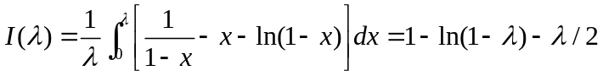

5.20
template <typename HashedObj, typename Object>
class Pair
{
public:
Pair(HashedObj k, Object d): key(k), def(d){}
private:
HashedObj key;
Object def;
// Appropriate Constructors, etc.
};

template <typename HashedObj, typename Object>
class Dictionary
{
public:
Dictionary( ) {}
void insert( const HashedObj & key, const Object & definition )
{items.insert(Pair<HashedObj,Object>(key, definition));}
const Object & lookup( const HashedObj & key ) const
{ return items.contains(key);}
bool isEmpty( ) const
{return items.isEmpty(); }
void makeEmpty( )
{ items.makeEmpty();}
private:
HashTable<Pair<HashedObj,Object> > items;
};
5.22 Consider the function on the random variable X, I_{a} (X) to be 1 if X> a, and 0 otherwise. I_{a}() is called an indicator random variable . If a > 0, then aI_{a}(X) < X since if X < a, the left size is 0 and if X > a we have a < X. Taking the expectation of both sides we have :
E(aI_{a}(X)) < E(X). Now using the definition of expectation,
E(aI_{a}(X)) = aE(1* Pr(X > a) + 0*Pr(X<a)) = aPr(X> a).
Thus aPr(X> a)< E(X) and dividing by a (since a was assumed greater than 0) we have
Pr(X> a) < E(X)/a.
Applying this to Theorem 5.3 we see that the probability of total size of the secondary hash tables (when N items are placed into a primary hash table containing N bins) , being greater than N, is at most ½.
5.23 The probability of a rehash (failed insertion) at the point when the table is half full is low, on the order of 1% or less. The probability falls with increased table size. Below are the results of two trials with random insertion data. The probabilities may be even lower if we modify the hopscotch table to continue linear probing past the end of the table to wrap around to the beginning.

Table size | MAX_DIST | Load factor | Number of trials | Probability of rehash
2⁷ – 1 = 63 | 2⁶ – 1 = 31 | 0.5 | 1,000,000 | 0.011000
2¹³ – 1 = 8191 | 2¹² – 1 = 4095 | 0.5 | 1,000,000 | 0.000194
5.24
template <typename AnyType>
class HopScotchHash
{
private :
vector<HashEntry<AnyType>> table;
int myHash(const AnyType & x) const
{
return ((int) x) % table.size();
}
bool shiftDown(int home, int open, AnyType & x)
{
int i = open - MAX_DIST;
int pos = (1<<MAX_DIST);
int D = table.size();
int tempHome;
AnyType temp;

while (i < open && table[(home + i)%D].hop>0)
i++;
if (i >= open) return false;
else
{
if (i<MAX_DIST)
{
table[(home + i)% D].element = x;
table[(home + i)% D].isActive = true;
table[home].hop = table[home].hop | (pos>>i);
return true;
}
else
{
temp = table[(home+i)%D].element;
tempHome = myHash(temp);
if (shiftDown(tempHome, i, temp))
{
table[(home+open)%D].element = temp;
table[tempHome].hop = table[tempHome].hop^ (1 << (home + open-tempHome)%D) |
(1<<(home+open - tempHome));
return true;
}// end if
return false;
}//end else
}// end else
}// end shiftdown
bool insert1(AnyType & x)
{
int pos = (1<<MAX_DIST);
int home = myHash(x);
int D = table.size();
int diff = 0;
while (diff < table.size() && table[(home + (diff))% D].isActive)
diff++;
if (diff >= table.size())
return false;
else if (diff<=MAX_DIST)
{
table[(home + diff)% D].element = x;
table[(home + diff)% D].isActive = true;
table[home].hop = table[home].hop | (pos>>diff);
return true;
}
else // need to relocate something else
{
return shiftDown(home, home + diff, x);
}

}// end of insert
public :
HopScotchHash(int size = 11)
{table.resize(size);}
bool insert(AnyType & x)
{
if (!insert1(x))
{
HopScotchHash<AnyType> temp(table.size()*2);
for (int i = 0; i < table.size(); i++)
temp.insert(table[i].element);
table = temp.table;
insert(x);
}
return true;
}

};
The amount of time to insert 10,000 elements for various sample implementations is given below. The advantage of hopscotch hashing is not in the computational efficiency of the average case.
Implementation | Time (ms)
Hopscotch | 150
Cuckoo | 991
Linear probing | 10
Separate chaining | 40

5.25
// To mimic the "classic" cuckoo hash table, as shown in the examples
// given in Figures 5.26-5.33 in the text,

#include<string>
#include<vector>
#include<cmath>
#include<iostream>
using namespace std;
const int LOGICAL_SIZE = 13;

class CuckooHashTable
{
private:
vector<vector<string>> contents;
int currentSize;
public:
CuckooHashTable():contents(LOGICAL_SIZE)
{
for (int i = 0; i < LOGICAL_SIZE; i++)
contents[i].resize(2);
currentSize = 0;
}

void makeEmpty()
{
for (int i = 0; i < contents.size(); ++i)
for (int j = 0; j < contents[0].size(); ++j)
contents[i][j] = "";
}

int hashCode(string value) // based on Javas hash value
{
int total = 0;
for (int i = 0; i < value.size(); i++)
total += value[i]*pow(31,value.size()-i-1);
return total;
}

// For Cuckoo hashing, we need to be ready to compute the value
// of an n-th hash code. Multiply the string's native hash code
// by the table number (e.g. 1 or 2...), and mod by the logical size.
// Here, we consider the "table number" to start at 1 because it
// would undesirable to multiply by 0.
int hashCode(string value, int which)
{
return (hashCode(value) * (which+1)) % LOGICAL_SIZE;
}

void add(string value)
{
cout<<"Entering add() with value = "<< value<<endl;

// The item automatically goes into the first logical table,
// i.e. the first column of our representation.
// But doing so may displace whoever is currently there.
int desiredCol = 0;
int desiredRow = hashCode(value, desiredCol);

while (true)
{
cout<<"contents["<<desiredRow<<"]["<<desiredCol<<"] = ";
cout<<contents[desiredRow][desiredCol]<<endl;

if (contents[desiredRow][desiredCol] == "")
{
contents[desiredRow][desiredCol] = value;
break;
}

// The case of having to evict something already there.
else
{
string victim = contents[desiredRow][desiredCol];
contents[desiredRow][desiredCol] = value;

// Put the victim in its "other" location in the next column.
desiredCol = (desiredCol + 1) % contents[0].size();
desiredRow = hashCode(value, desiredCol);

cout<<"Need to replace a victim: "<< victim<<endl;
cout<<" new row/col = ["<<desiredRow<<"]["<<desiredCol <<"]\n";
}
}
}
}
5.26 To support d hash functions, the only modification necessary in the implementation given in 5.25 is to change the way the “contents” array is allocated in the CuckooHashTable constructor, so that it has d columns instead of 2 columns. The new statement should read:
contents = new String [LOGICAL_SIZE][d];
5.27
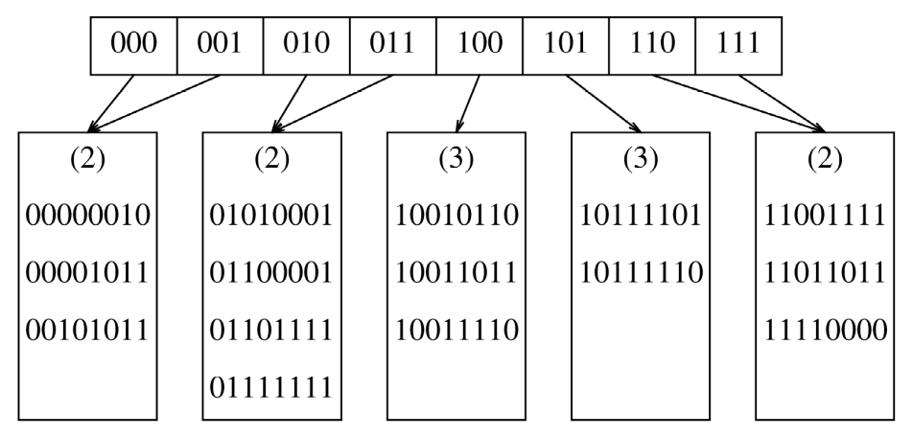
5.28
/*
Extensible hashing
Assumes the number of bits is INT_BITS
*/

#include <iostream>
#include <algorithm>
#include <cmath>
#include <vector>
using namespace std;

const int BLOCKSIZE = 4;
const int INT_BITS = 32;
struct Node
{
vector<int> data;
Node() { }
};
struct Directory
{
vector<Node *> pointers;
int numSigBits;
Directory() {};
Directory(int size)
{
resize(size);
numSigBits = floor(log(size)/log(2)+.5);
}
int size() {return pointers.size();}
void resize(int size)
{
pointers.resize(size);
for (auto & p : pointers)
p = nullptr;
numSigBits = floor(log(size)/log(2)+.5);
}
};

class ExtendHash
{
private:
Directory directory;
int getKey(int data, int size)
// returns the first size bits of data as
// base 10 integer
{
data = data >> (INT_BITS - size);
return data;
}
void doubleDirect()
{
Directory temp(2*directory.size());
for (int i = 0; i < directory.size(); i++)
{
temp.pointers[2*i] = directory.pointers[i];
temp.pointers[2*i+1] = directory.pointers[i];
}
directory.numSigBits= directory.numSigBits+1;
directory.pointers = temp.pointers;
}
public:
ExtendHash() { directory.resize(2); directory.numSigBits = 1;}
void insert(int d)
{
int key = getKey(d, directory.size());
while (key >= directory.size())
{
doubleDirect();
key = getKey(d, directory.numSigBits);
}

Node * p = directory.pointers[key];
if (directory.pointers[key] == nullptr)
{
directory.pointers[key] = new Node();
p = directory.pointers[key];
}
if (p->data.size() < BLOCKSIZE )
p->data.push_back(d);
else
{
for (int i = 0; i < directory.pointers.size(); i++)
if (i != key && directory.pointers[key] == directory.pointers[i])
{
vector<int> tempBlock = p->data;
p->data.clear();
directory.pointers[i] = new Node;
for (auto x : tempBlock)
insert(x);
insert(d);
return ;
}
doubleDirect();
insert(d);
}
}
void print()
{
for (int i = 0; i < directory.pointers.size(); i++)
{
cout<<"block #"<<i<<endl;
if (directory.pointers[i] != nullptr)
{
for (auto x : directory.pointers[i]->data)
cout<< x<<endl;
}
}
}
};

int main()
{
ExtendHash table;
for (int i = 0; i < 30; i++)
{
table.insert(i*8);
}
table.print();
return 0;
}

